

Fundraising Support Administrator

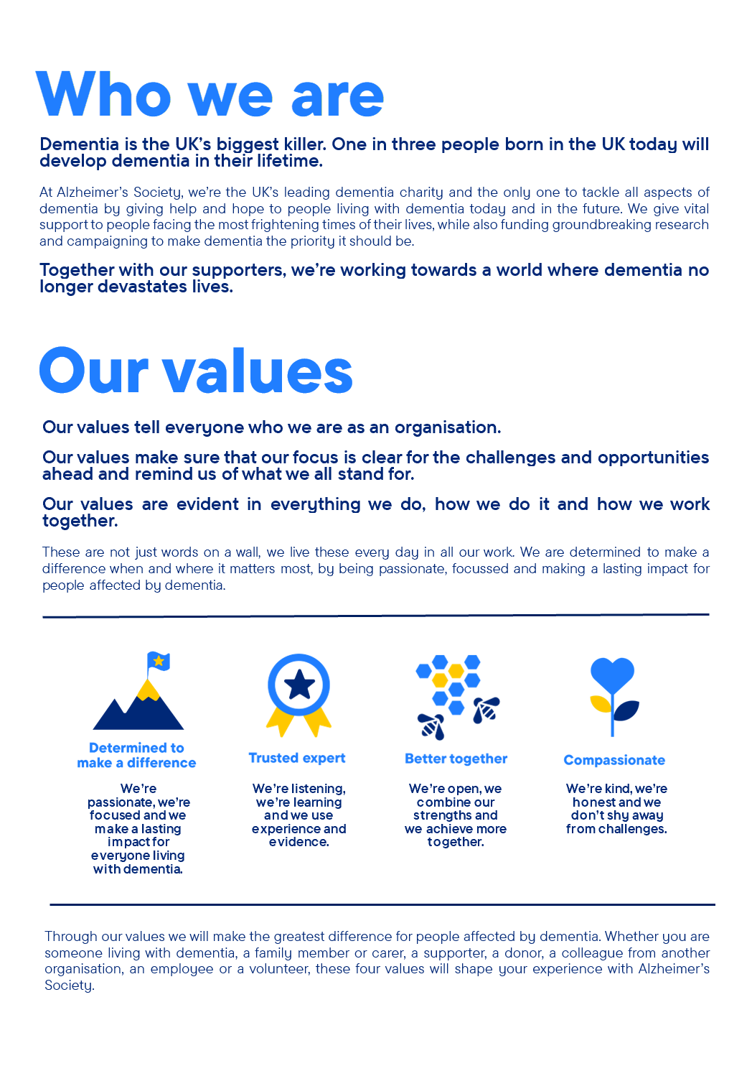

Fundraising Support Administrator

Position in the organisation
Reports to the Fundraising and Marketing Support Team Leader
Member of our Mass Acquisition and Engagement
Part of our Income and Engagement Directorate

Purpose of this role
At Alzheimer’s Society we are advisors, supporters, fundraisers, researchers, influencers, communicators, technical specialist and so much more. We are volunteers, we are employees, and together we are here to make a difference to the lives of people with dementia and their carers.

We are looking for someone who can deliver excellent support to Alzheimer’s Society Fundraising teams. We do this through centralised administrative support, complaint handling, answering queries, financial donation handling, processing & thanking donations, maintaining accurate database records that reflect and enhance the customer experience, and ensuring the deliverance of excellent supporter care.

We are looking for someone who exemplifies our values, someone who is: Determined to make a difference when and where it matters most. A trusted expert who believes in working Better together and demonstrates true Compassion.

Key accountabilities and responsibilities
◼ Handle all enquiries by telephone, letter, and email. Ensure that all enquiries, including feedback and complaints are handled within agreed standards.
◼ Process fundraising income (including cheques, direct debits, and gift aid) accurately onto our fundraising database within agreed timescales.
◼ Financial processing, including cash and cheque handling.
◼ Create or amend supporter records on the database in an accurate manner and within agreed standards.
◼ Work closely with colleagues in the Supporter Engagement department to ensure all work enhances the supporter journey.
◼ Ensure all filing and paperwork storage is maintained to the highest standards for audit purposes and complies with the Records Retention and Disposal Schedule.
◼ To act as an innovation hub and assist other parts of the Fundraising and Marketing directorate with their administration and fulfilment of campaigns.
◼ Managing individual projects which will look to improve team processes.

We are looking for someone who can…
- Adhere to all the Society’s service standards, policies and procedures.
- Comply with the data protection regulations, ensuring that information on clients remains confidential.
- Be responsible for personal learning and development, to support the learning and development of others and the whole organisation.
- Work in a manner that facilitates inclusion, particularly of people with dementia.
- Implement the Society’s health and safety policy and procedures, ensuring that all practices and procedures are undertaken in accordance with a healthy and safe working environment and that all staff and volunteers for whom you may be responsible are aware of their responsibilities in respect of their role, monitoring data and recommending action as required.
- Administrate and organise own work to ensure that it is accurate and meets quality targets, reasonable deadlines, and reporting requirements.
- Follow the Society’s management information guidelines and requirements, including ensuring appropriate monthly measures on service usage levels are collected and submitted on the services database or other systems in accordance with deadlines.

Person specification and selection criteria
Skills & knowledge | Application (A) or Interview (I)
Numerate and literate, with good standard of education or  relevant experience | A/I
Strong data inputting ability and general use of databases | A/I
Experience of working in a supporter relations or customer  service environment | A/I
Ability to manage difficult conversations, gather information and  find suitable solutions to enable complaint resolution. | A/I
Able to demonstrate experience in adhering to procedures and  processes | A/I
Ability to communicate effectively verbally, face to face, over the  telephone, and in writing | A/I
Strong relationship skills including the ability to develop and  maintain key relationships | A/I
Good understanding of the importance of financial processing | A/I
Knowledge of Microsoft packages (including Outlook, Word,  Excel, and Teams) | A/I
Working knowledge of Data Protection regulations | A/I
Able to compose letters to supporters with a high level of  accuracy | A/I
Ability to plan, prioritise and work to deadlines under pressure | A/I
Ability to problem solve and act on own initiative | A/I

Competencies & personal attributes | Application (A) or interview (I)
Have strong IT skills and experience. | A/I
Be a self-starter and incredibly motivated. | A/I
Excellent organisational and timekeeping skills. | A/I
Excellent attention to detail. | A/I
Non-judgemental communication | A/I
Be a team player, supporting colleagues when there are deadlines, and who knows when to ask for help themselves. | A/I

Follow us on Twitter and Instagram @Alzheimerssoc and Like us on Facebook or check out Alzheimer’s Society YouTube channel youtube.com/AlzheimersSociety
Criminal Record Check
This post may be subject to a satisfactory Criminal Records Check, from either the Disclosure and Barring Service (England & Wales), Disclosure Scotland Check (Scotland) or AccessNI (Northern Ireland). Please select the level of Check required for this role:
Basic ☐
Enhanced ☐
Not Applicable ☒
Candidates - If you require further information regarding Criminal Records Check, then please contact: careers@alzheimers.org.uk
Hiring Managers - If you require further information regarding Criminal Records Check for this role, then please contact: Employeesupport@alzheimers.org.uk

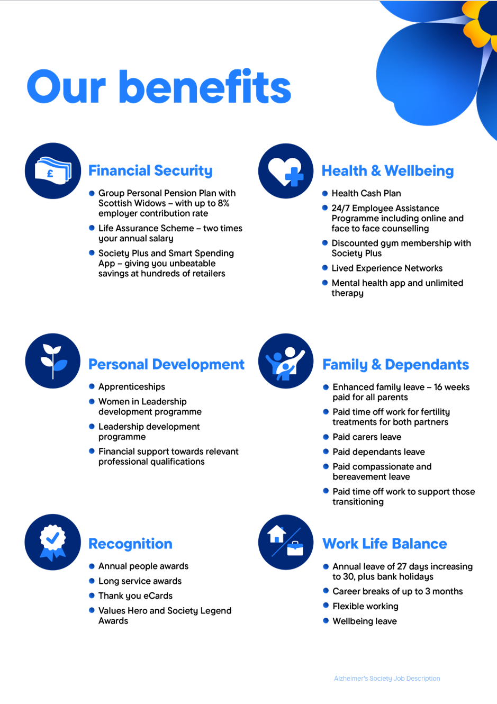
https://www.alzheimer

