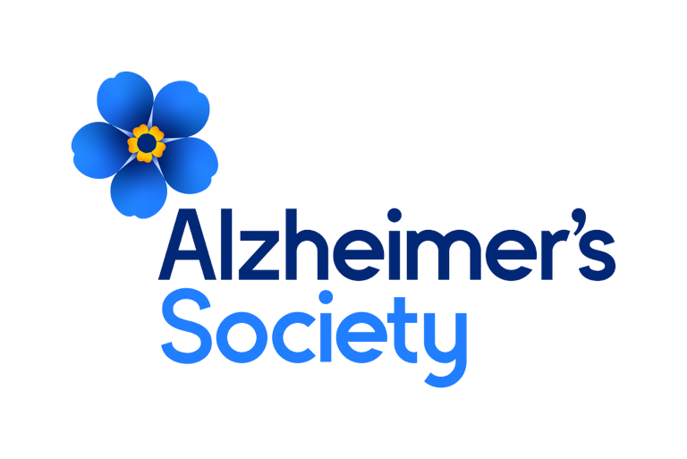
Trial Finder Officer – FTC 24 months


It will take a society to beat dementia. Alzheimer’s Society.
Job description

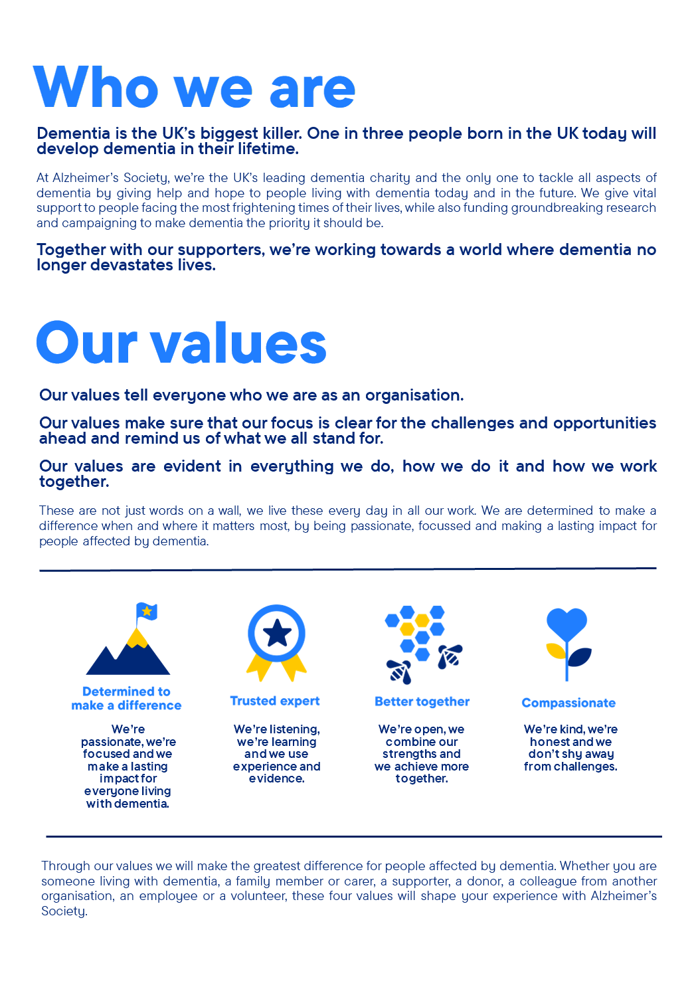

Trial Finder Officer

Position in the organisation
This post reports to the Research Participation Manager and is part of the Research and Influencing (R&I) directorate.

The postholder will work closely with the Research Nurse Programme, the Research Communications team, the wider Participation team and external UK Dementia Trials Network colleagues to maintain the Alzheimer’s Society UKDTN Trial Finder platform and raise awareness of clinical trial opportunities in mild cognitive impairment and dementia available across the United Kingdom.

Purpose of this role
At Alzheimer’s Society we are advisors, supporters, fundraisers, researchers, influencers, communicators, technical specialist and so much more. We are volunteers, we are employees, and together we are here to make a difference to the lives of people with dementia and their carers.

The Alzheimer’s Society UKDTN Trials Finder is an online, open access, platform hosted on Alzheimer’s Society’s website and funded by the UK Dementia Trials Network (the UKDTN). The Trials Finder will provide people affected by mild cognitive impairment or dementia, their loved ones, and healthcare professionals with information about available clinical trials, including details of how they can contact our Research Nurses and the appropriate NHS teams to express an interest in taking part in a trial. The Trials Finder will play a key role in achieving the UKDTN and the Society’s ambition of enabling more people living with dementia to access and engage with appropriate clinical research opportunities regardless of where they live.
Passion for improving awareness of, and access to, dementia clinical research opportunities is vital as is confidence in working across a wide range of clinical and research stakeholders to manage competing demands effectively. Managing the day-to-day running of the Trials Finder, the post-holder will work closely with colleagues from across the Society and UKDTN patient workstream to ensure all study listings are accessible and accurate and there is appropriate supporting content available across the Society’s website. There will be an occasional requirement to support the Research Communications team with communications activity relating to the Clinical Trials Finder.
We are looking for someone who exemplifies our values, someone who is: Determined to make a difference when and where it matters most. A trusted expert who believes in working Better together and demonstrates true Compassion.

Key accountabilities and responsibilities
- Oversee the day-to-day operation of the Trials Finder, ensuring it is reliable, up to date, and easy for users to navigate.
- Maintain accurate and accessible study listings, ensuring all information is clearly presented and approved by study sponsors prior to use.
- Implement and manage quality control processes, including version control, audit trails, and regular review of trial entries.
- Monitor user issues and feedback, resolving information gaps and escalating technical problems, while driving continuous improvements based on user insights and analytics.
- Liaise with external stakeholders (e.g., clinicians, NHS research teams, study sponsors) to verify trial details and keep enquiry routes and site information accurate.
- Work collaboratively with Alzheimer’s Society teams and the UKDTN patient workstream to coordinate updates, maintain consistency, and respond to queries.
- Maintain accurate internal records and datasets, including updates to study listings and associated communications.
- Track and report key metrics on Trials Finder usage, reach, and impact.
- Support related Research Communications activity, such as web updates, newsletters, social media content or media requests.
- Ensure compliance and accessibility, following ethical, governance, and branding standards, embedding accessibility-by-design, and keeping knowledge of dementia clinical research up to date through relevant training.

We are looking for someone who can…
- Adhere to all the Society’s service standards, policies and procedures.
- Comply with the data protection regulations, ensuring that information on clients remains confidential.
- Be responsible for personal learning and development, to support the learning and development of others and the whole organisation.
- Work in a manner that facilitates inclusion, particularly of people with dementia.
- Implement the Society’s health and safety policy and procedures, ensuring that all practices and procedures are undertaken in accordance with a healthy and safe working environment and that all staff and volunteers for whom you may be responsible are aware of their responsibilities in respect of their role, monitoring data and recommending action as required.
- Administrate and organise own work to ensure that it is accurate and meets quality targets, reasonable deadlines, and reporting requirements.
- Follow the Society’s management information guidelines and requirements, including ensuring appropriate monthly measures on service usage levels are collected and submitted on the services database or other systems in accordance with deadlines.

Person specification and selection criteria
Skills & knowledge | Application (A) or Interview (I)
Educated to degree level in a relevant biomedical or health discipline, or relevant experience in life sciences, research delivery or communications. | A
Strong written and verbal communication skills, with the ability to credibly explain complex or scientific information clearly for a range of internal and external stakeholders including people affected by dementia. | A, I
Knowledge and understanding of clinical research delivery within NHS, academic or private sector | A
Experience managing multiple competing tasks with high accuracy, combined with excellent attention to detail and strong organisational skills. | A, I
Able to build effective, professional working relationships with internal and external stakeholders including clinicians, researchers and study sponsors | A, I
Able to work independently and to take a proactive and solution focussed approach to new projects | A, I
Ability to plan, prioritise and deliver projects to tight timescales | A, I
Able to empathise with people affected by dementia, and those who support them, dealing sensitively with enquiries related to Trial Finder. | A, I
Excellent IT skills, including Microsoft Office 365. | A
Experience maintaining public-facing research databases. | A

Competencies & personal attributes | Application (A) or interview (I)
Be a team player, supporting colleagues when there are deadlines, and who knows when to ask for help themselves. | A, I
Be a self-starter and incredibly motivated. | A, I
Excellent organisational and timekeeping skills. | A, I
Excellent attention to detail. | A, I
Non-judgemental communication | A, I
Commitment to and understanding of equal opportunities | A, I
Understanding of the inclusion agenda and its relevance within a diverse society | A, I

Follow us on Twitter and Instagram @Alzheimerssoc and Like us on Facebook or check out Alzheimer’s Society YouTube channel youtube.com/AlzheimersSociety
Criminal Record Check

This post may be subject to a satisfactory Criminal Records Check, from either the Disclosure and Barring Service (England & Wales), Disclosure Scotland Check (Scotland) or AccessNI (Northern Ireland). Please select the level of Check required for this role:

Basic ☐
Enhanced ☐
Not Applicable ☐
Candidates - If you require further information regarding Criminal Records Check, then please contact: careers@alzheimers.org.uk
Hiring Managers - If you require further information regarding Criminal Records Check for this role, then please contact: Employeesupport@alzheimers.org.uk


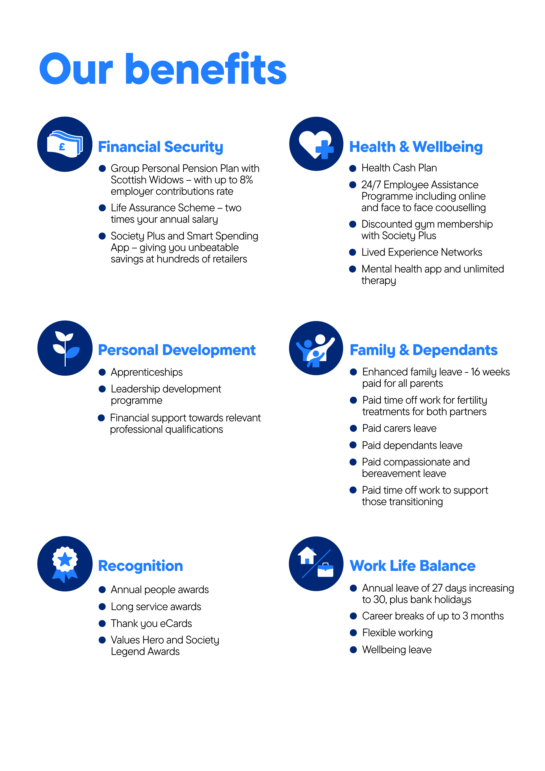
https://www.alzheimers.org.uk/sites/default/files/2024-08/alzheimers-society-how-to-talk-about-dementia-media-guide.pdf

