

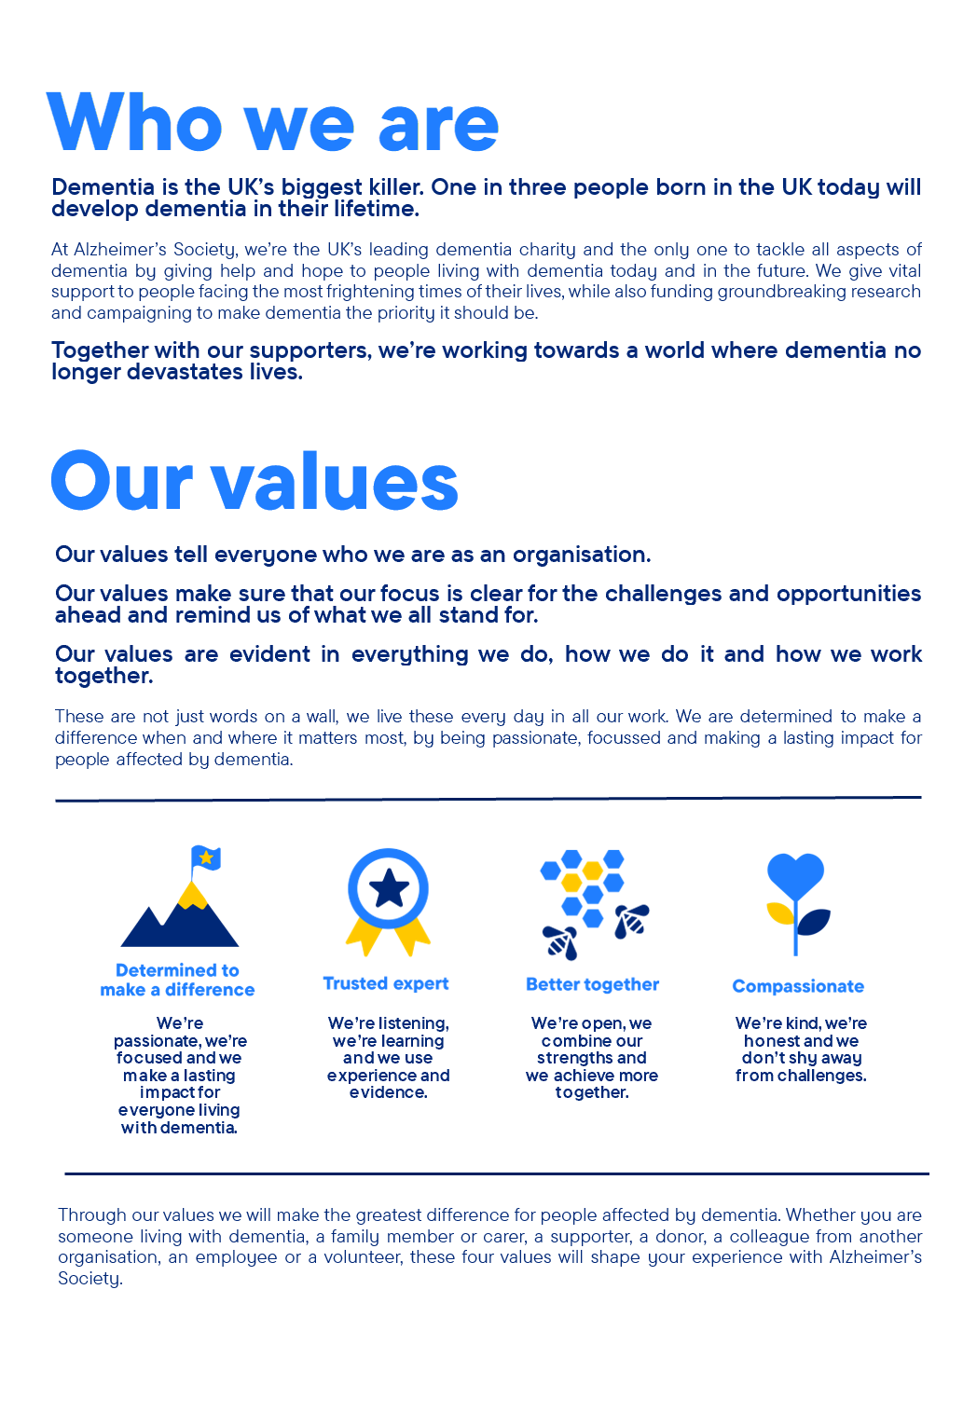

Special Events Officer

Position in the organisation
Reports to the Special Events Manager
Member of our Special Events team
Part of our Income & Engagement Directorate

Purpose of this role
At Alzheimer’s Society we are advisors, supporters, fundraisers, researchers, influencers, communicators, technical specialist and so much more. We are volunteers, we are employees, and together we are here to make a difference to the lives of people with dementia and their carers.

We are looking for someone who exemplifies our values, someone who is: Determined to make a difference when and where it matters most. A trusted expert who believes in working Better together and demonstrates true Compassion.

Key accountabilities and responsibilities
Event Support
- Evaluate the short and long term impact of engagement events with clear analysis, feedback and evidence, making recommendations for future events to the Special Events manager
- Ensure that the events that we deliver are inclusive for all
- Work with the Special Events team and event volunteers to provide exceptional experiences for our attendees, meeting agreed impact and success measures.
- End to end Event Management admin including but not limited to: venue sourcing, volunteer recruitment, development of print items and deadlines, guest list management.
- Work out of normal office hours as required by the special events programme, including attending and supporting evening events in London and working from our London office on a regular basis.
- Undertake any other tasks that are required with the level of this post as required by the Special Events Manager and Senior Special Events Manager
- Provide in person support for all London events across the year, including setup, guest management, on the day delivery, and pack down.
- Lead on the planning and delivery of selected events, with support from the Special Events Manager.
Stakeholder management:
- Work across departments to improve and develop processes, systems and relationships which enable the effective day to day management of Special Events and the long-term strategic goals of the Special Events Team.
- Work with stakeholders across and beyond fundraising to encourage participation and learnings from all experiences
- Work with senior stakeholders across High Value to contribute to the team strategy and business planning processes
- Represent Alzheimer’s Society at both internal and external events, meetings, and presentations

Other
- Act as part of an expert resource on events fundraising for Alzheimer’s Society staff and supporters.
- Be responsible for in office administration duties, including document preparation, guest list management, supplier coordination, and event pack logistics from our London office.
- Undertake any other tasks that are commensurate with the level of this post as required.
- Act as part of an expert resource on engagement events for Alzheimer’s Society staff and supporters
- Lead on maintaining and managing the inventory of event materials, including regular stock takes and ensuring readiness of assets, supplies and printed materials for use at events.
- Coordinate event logistics and materials from our London office, including shipping, packing, printing, and storage organisation.

We are looking for someone who can…
- Adhere to all the Society’s service standards, policies and procedures.
- Comply with the data protection regulations, ensuring that information on clients remains confidential.
- To champion the diverse needs of people affected by dementia by working in a manner that facilitates inclusion and collaboration, within and beyond the Society.
- To support and enable volunteering activities.
- To implement the Society’s health and safety policy and procedures, ensuring that all practices and procedures are undertaken in accordance with a healthy and safe working environment and that all staff and volunteers for whom you may be responsible are aware of their responsibilities in respect of their role, monitoring data and recommending action as required.
- To be responsible for personal learning and development, to support the learning and development of others and the whole organisation.
- To administrate and organise own work to ensure that it is accurate and meets quality targets, reasonable deadlines and reporting requirements.
- Work to embed a culture of inclusion and collaboration, within and beyond the Society.

Person specification and selection criteria
Skills & knowledge | Application (A) or Interview (I)
Demonstrable experience of supporting engagement events that aim to engage a target audience and meet objectives | A/I
Excellent communication skills, both written and verbal including presentation skills | A/I
Significant experience of managing multiple projects at once, working to deadlines and performing well under pressure | A/I
Interest in new event technologies including virtual and hybrid events | A/I
Ability to use initiative, prioritise and demonstrate a problem solving approach | A/I
Ability to demonstrate sound judgement based and make recommendations based on knowledge and insight | A/I
Knowledge of events fundraising | A/I
Experience of supervising staff or volunteers within an events environment | A/I
Knowledge with MS Office and fundraising databases | A/I
Proactively build relationships with internal and external stakeholders and supporters at all levels | A/I
Experience working with high value fundraising teams, including corporate partnerships, legacy, and philanthropy. | A/I

Competencies & personal attributes | Application (A) or interview (I)
Excellent communication skills, both verbal and written | A/I
Work collaboratively and be able to prioritise your workload effectively and remain solution focussed throughout your areas of work. | A/I
Excellent organisational and timekeeping skills. | A/I
Excellent attention to detail. | A/I
A collaborative team player who supports colleagues during busy periods and tight deadlines, and confidently seeks support when needed. | A/I
Be a self starter and incredibly motivated. | A/I

Follow us on Twitter and Instagram @Alzheimerssoc and Like us on Facebook or check out Alzheimer’s Society YouTube channel youtube.com/AlzheimersSociety

Criminal Record Check
This post may be subject to a satisfactory Criminal Records Check, from either the Disclosure and Barring Service (England & Wales), Disclosure Scotland Check (Scotland) or AccessNI (Northern Ireland). Please select the level of Check required for this role:
Basic ☐
Enhanced ☐
Not Applicable ☐
Candidates - If you require further information regarding Criminal Records Check, then please contact: careers@alzheimers.org.uk
Hiring Managers - If you require further information regarding Criminal Records Check for this role, then please contact: Employeesupport@alzheimers.org.uk

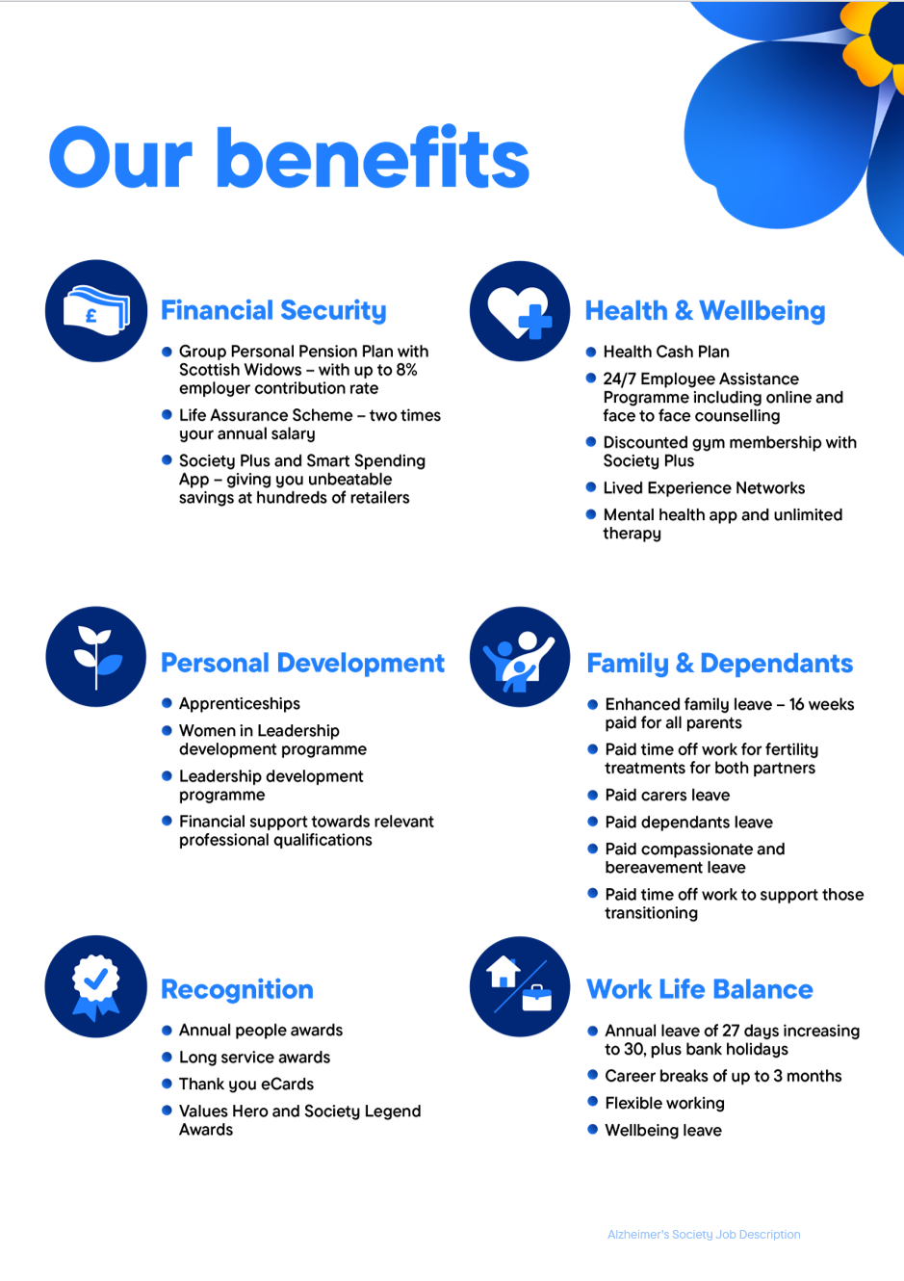
https://www.alzheimer

