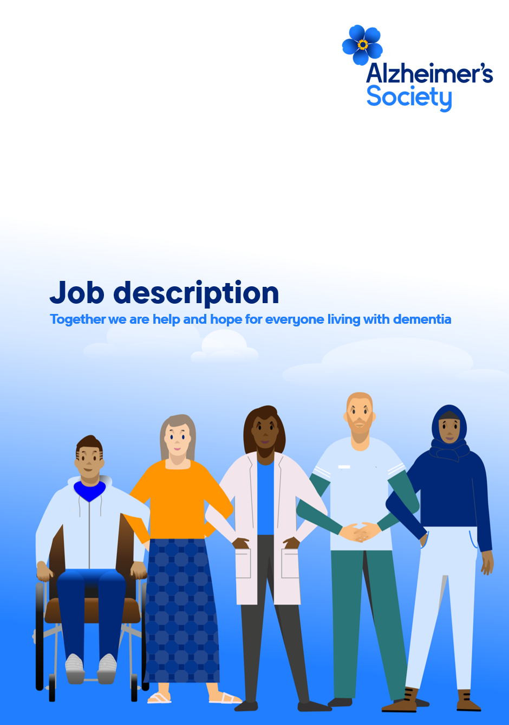

Employee Support Assistant

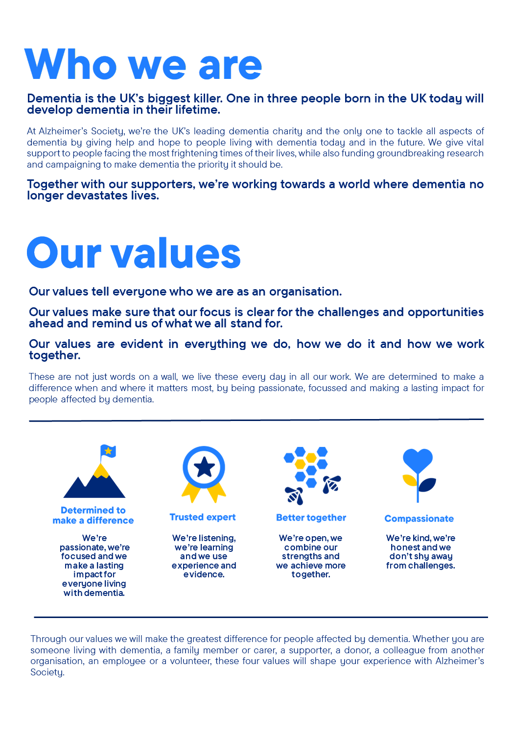

Employee Support Assistant

Position in the organisation
Reports to the
Employee Support Team Leader
People

Purpose of this role
At Alzheimer’s Society we are advisors, supporters, fundraisers, researchers, influencers, communicators, technical specialist and so much more. We are volunteers, we are employees, and together we are here to make a difference to the lives of people with dementia and their carers.

Employee Support are the first point of contact for our employees; we support them to navigate the systems and processes that are part of working for or with the Society, from when people join us through to leaving. We provide advice and support to managers and individuals on our policies & processes, making things easier and clearer for everyone as we deliver our work for people affected by dementia.

Employee Support has a critical role in ensuring that the information that we hold in our systems about our people is accurate and up to date. The Society relies on the data we hold in people systems for payroll, effective business management and compliance/reporting.

As Employee Support Assistant, you will be the first point of contact for system & process administration and enquiries, signposting managers & employees to information & guidance. You will ensure employee documentation follows statutory & best practice requirements and provide first line HR advice as required.

We are looking for someone who exemplifies our values, someone who is: Determined to make a difference when and where it matters most. A trusted expert who believes in working Better together and demonstrates true Compassion.

Key accountabilities and responsibilities
- Act as the first point of contact for all enquiries, via central email accounts, related to employment & management.
- Signpost employees and managers to relevant policies & information.
- Responsible for triaging enquiries to the relevant specialist teams in POD where appropriate.
- Process employee changes, following relevant processes.
- Update our People System, ensuring a high level of data quality is maintained.
- Ensure key deadlines are met such as payroll processing dates & service standards.
- Monitor data reports and ensure compliance with key processes.
- Process & monitor Criminal Record Checks for our employees and contractors.
- Support users of the people system, enabling them to efficiently and accurately process people data to agreed standards.
- Maintain knowledge management systems within the team, keeping appropriate records and filing systems and ensuring they comply with all data protections regulations.
- Contribute to the review and continuing improvement of team working practices and processes, proactively identify better ways of working.
- Play a part in the delivery of the POD vision by contributing to and supporting projects in the directorate and team business plans.
- To undertake any other duties or projects commensurate with the nature and grade of this post as required.

We are looking for someone who can…
- Adhere to all the Society’s service standards, policies and procedures.
- Comply with the data protection regulations, ensuring that information on clients remains confidential.
- To champion the diverse needs of people affected by dementia by working in a manner that facilitates inclusion and collaboration, within and beyond the Society.
- To support and enable volunteering activities.
- To implement the Society’s health and safety policy and procedures, ensuring that all practices and procedures are undertaken in accordance with a healthy and safe working environment and that all staff and volunteers for whom you may be responsible are aware of their responsibilities in respect.
- of their role, monitoring data and recommending action as required.
- To be responsible for personal learning and development, to support the learning and development of others and the whole organisation.
- To administrate and organise own work to ensure that it is accurate and meets quality targets, reasonable deadlines and reporting requirements.
- Work to embed a culture of inclusion and collaboration, within and beyond the Society

Person specification and selection criteria
Skills & knowledge | Application (A) or Interview (I)
Experience of working in a customer focused administration role | A/I
Experience of working in a Human Resources administration role | A/I
Experience of developing good working relationships with colleagues and customers | A/I
Experience of using a human resources system/database or other type of database | A/I
Experience in using Microsoft office suite including Word and Excel | A/I
Ability to explain complex and technical information clearly and simply | A/I
Experience of working with confidential information and an understanding of data protection principles | A/I
An understanding of and a commitment to equal opportunities | A/I

Competencies & personal attributes | Application (A) or interview (I)
Able to work as part of a team and contribute to shared goals | A/I
Takes a continuous improvements approach to processes and procedures, regularly identifying and recommending positive changes | A/I
Ability to think creatively and problem solve | A/I
Excellent attention to detail | A/I
Resilient and responsive to changing demands | A/I
Excellent communication skills; able to communicate verbally and in writing to a variety of audiences | A/I
Able to work as part of a team and contribute to shared goals | A/I

Follow us on Twitter and Instagram @Alzheimerssoc and Like us on Facebook or check out Alzheimer’s Society YouTube channel youtube.com/AlzheimersSociety
Criminal Record Check
This post may be subject to a satisfactory Criminal Records Check, from either the Disclosure and Barring Service (England & Wales), Disclosure Scotland Check (Scotland) or AccessNI (Northern Ireland). Please select the level of Check required for this role:
Basic ☐
Enhanced ☐
Not Applicable ☒
Candidates - If you require further information regarding Criminal Records Check, then please contact: careers@alzheimers.org.uk
Hiring Managers - If you require further information regarding Criminal Records Check for this role, then please contact: Employeesupport@alzheimers.org.uk

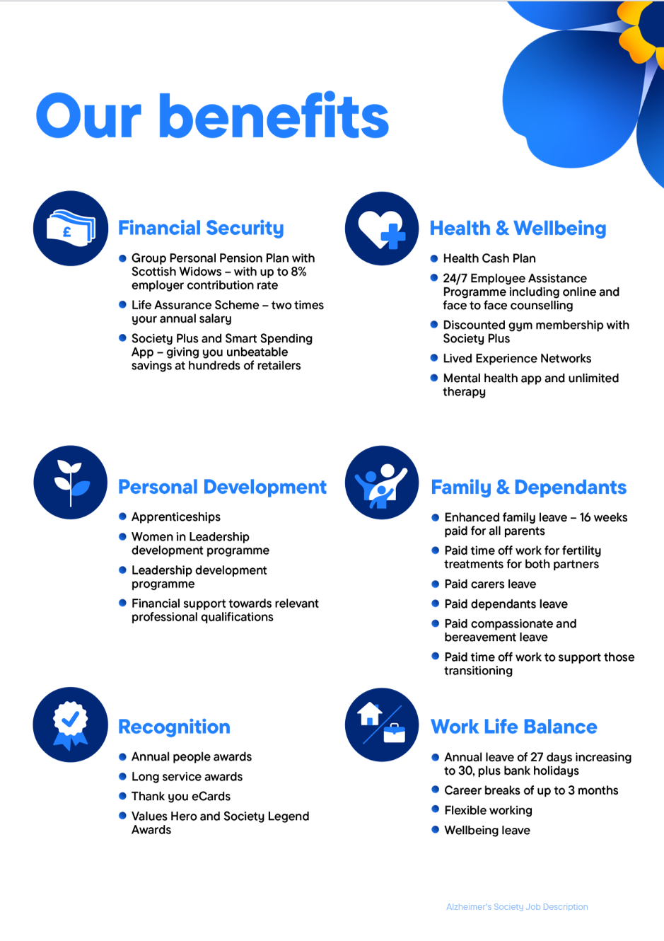
https://www.alzheimer

