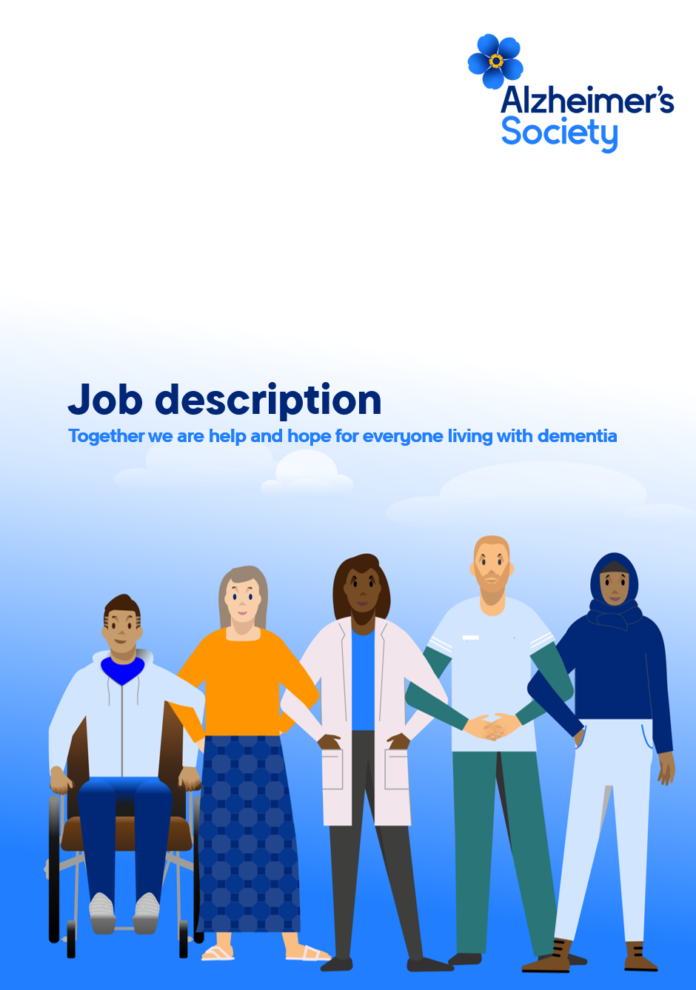
Legacy Marketing Executive

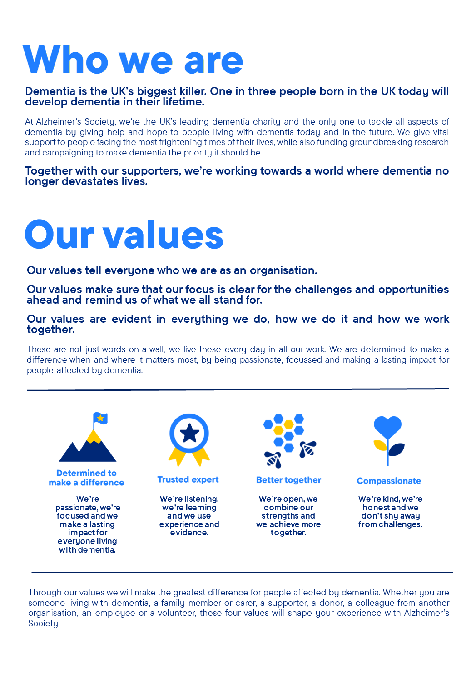

Legacy Marketing Executive

Position in the organisation
Reports to the Legacy Marketing Manager
Member of our Legacy Marketing team.
Part of our Income and Engagement directorate.

Purpose of this role
At Alzheimer’s Society we are advisors, supporters, fundraisers, researchers, influencers, communicators, technical specialist and so much more. We are volunteers, we are employees, and together we are here to make a difference to the lives of people with dementia and their carers.

This role specifically will provide marketing support and project management of marketing campaigns to promote Legacy Giving (Gifts in Wills) and our free Will-writing scheme. The successful candidate will be responsible for supporting the implementation of the Legacy team marketing plan and working with internal teams and external suppliers and agencies. This will contribute to the overall Alzheimer’s Society fundraising strategy and create future sustainable income by increasing the number of legacy gifts left to the Society.
We are looking for someone who exemplifies our values, someone who is: Determined to make a difference when and where it matters most. A trusted expert who believes in working Better together and demonstrates true Compassion.

Key accountabilities and responsibilities
- Personal ownership of developing and delivering effective multi-channel marketing communications campaigns and projects. This includes creative development, targeting strategy, data selection and segmentation, planning fulfilment, and monitoring results.
- Briefing, performance management, and relationship building with key external suppliers (e.g. creative & media agencies, mailing & fulfilment houses) and internal marketing teams (e.g. Database Support, Web and Digital, Supporter Care, Customer Insight, other Fundraising teams) to deliver marketing campaigns and projects.
- Continual monitoring of campaign expenditure and results in line with targets e.g. ROI, cost per pack, response rates, legacy pledges. Conducting rigorous post campaign evaluation to make recommendations for future testing.
- Meeting cross-team KPIs including legacy enquirers, considerers, intenders, pledgers, and Will-writing scheme sign-ups.
- Utilising insight and analysis to identify trends and opportunities, champion the needs of the supporter, and lead on innovation within your areas of responsibility.
- Contributing ideas to the development of the Legacy Giving strategy and plans, and inputting to the annual budget planning process.
- Building an excellent close working relationship with the Regional Legacy Giving and Legacy Case teams – providing marketing support and facilitating ongoing stewardship of legacy supporters.
- Ensuring all work and materials produced are compliant, following external and internal regulations and guidelines (e.g. data protection, Fundraising Regulator, logos, required copy, brand guidelines, use of fundraising database).
- Proactively keeping abreast of competitor activities, new initiatives and sector trends and use these to proactively suggest improvements and innovations in your campaigns and projects.
- Consistently displaying passion and knowledge for best practice marketing and communication principles
- Displays professionalism as a representative of the Legacy Marketing team in internal and external meetings

We are looking for someone who can…
- Adhere to all the Society’s service standards, policies and procedures.
- Comply with the data protection regulations, ensuring that information on clients remains confidential.
- Be responsible for personal learning and development, to support the learning and development of others and the whole organisation.
- Work in a manner that facilitates inclusion, particularly of people with dementia.
- Implement the Society’s health and safety policy and procedures, ensuring that all practices and procedures are undertaken in accordance with a healthy and safe working environment and that all staff and volunteers for whom you may be responsible are aware of their responsibilities in respect of their role, monitoring data and recommending action as required.
- Administrate and organise own work to ensure that it is accurate and meets quality targets, reasonable deadlines, and reporting requirements.
- Follow the Society’s management information guidelines and requirements, including ensuring appropriate monthly measures on service usage levels are collected and submitted on the services database or other systems in accordance with deadlines.

Person specification and selection criteria
Skills & knowledge | Application (A) or Interview (I)
Experience of developing and delivering complex direct marketing communications | AI
Direct experience of working in a Legacy Marketing, Individual Giving or Direct Marketing team within a charity | AI
Proven track record of managing multi-channel marketing campaigns – both offline and digital. | AI
Detailed understanding of acquisition and retention techniques | AI
Up to date knowledge of the fundraising sector and a demonstrable interest in legacy fundraising | AI
Proactive approach to making improvements, including experience of delivering A/B testing and innovation. | AI
Experience of data segmentation and planning, campaign analysis and optimisation. | AI
Experience in using Microsoft Office, with particular emphasis on using Microsoft Excel. | AI
Experience in using CRM and Email Marketing software | AI
Strong creative judgement and understanding of key marketing and communications principles. | AI
Experience of managing day to day relationships with agencies and suppliers (eg. print, creative, media, telemarketing) | AI
Working knowledge of data protection regulation and industry best practice including GDPR. | AI
Able to undertake occasional travel and overnight stays as required. | AI

Competencies & personal attributes | Application (A) or interview (I)
Be a team player, supporting colleagues when there are deadlines, and who knows when to ask for help themselves. | AI
Be a self-starter and incredibly motivated. | AI
Excellent organisational and timekeeping skills. | AI
Excellent attention to detail. | AI
Non-judgemental communication | AI
Commitment to and understanding of equal opportunities | AI
Understanding of the inclusion agenda and its relevance within a diverse society | AI
Follow us on Twitter and Instagram @Alzheimerssoc and Like us on Facebook or check out Alzheimer’s Society YouTube channel youtube.com/AlzheimersSociety
