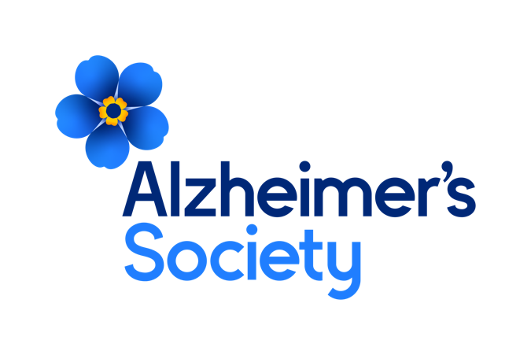

**Together we are help and hope for everyone living with dementia**

**Senior Regional Fundraising Manager – South**

**Who we are**

**Our values**

**Dementia is the biggest health and social challenge of our time.**

There are currently estimated to be 900,000 people in the UK with dementia. Many are undiagnosed and facing the realities of their condition alone.

At Alzheimer’s Society we’re working towards a world where dementia no longer devastates lives. We do this by giving help to those living with dementia today and providing hope for the future.

We’re here for everyone living with dementia.

As a Society, we are made up of people with dementia, carers, trusted experts, campaigners, researchers and clinicians. We are the UK’s largest collective force of people with unparalleled knowledge and over 40 years of experience addressing the biggest challenges facing people living with dementia.

**Together we are help and hope for everyone living with dementia.**

Our values tell everyone who we are as an organisation. Our values make sure that our focus is clear for the challenges and opportunities ahead and remind us what we all stand for. Our values are evident in everything we do, how we do it and how we work together.

These are not just words on a wall, we live these every day in all our work. We are Determined to make a difference when and where it matters most, by being passionate, focussed and making a lasting impact for people affected by dementia.



**We’re passionate, we’re focused and we make a lasting impact for everyone living with dementia.**



**We’re listening, we’re learning and we use experience and evidence.**



**We’re open, we combine our strengths and we achieve more together.**



**We’re kind, we’re honest and we don’t shy away from challenges.**

Through our values we will make the greatest difference for people affected by dementia. Whether you are someone living with dementia, a family member or carer, a supporter, a donor, a colleague from another organisation, an employee or a volunteer, these four values will shape your experience with Alzheimer’s Society.

**Position in the Organisation**

**Senior Regional Fundraising Manager**

Reports to the Head of Regional Fundraising  
Member of our Mass acquisition and engagement team.  
Part of our Income and Engagement directorate.

**Purpose of this Role**

We are here for anyone affected by dementia to help them navigate some of the hardest and most frightening times of their lives.

We are advisors, supporters, fundraisers, researchers, influencers, communicators, technical specialist and so much more. We are volunteers, we are employees, and together we are here to make a difference to the lives of people living with dementia and their carers.

As the Senior Fundraising Manager, you will be responsible for leading a high-performing team of Regional Fundraisers, driving strategy and ensuring the delivery of ambitious fundraising goals. Your role will focus on devising and implementing fundraising strategies, driving team performance, and working collaboratively both internally and externally to ensure success across key income streams. By providing strong leadership, fostering a culture of accountability, and actively seeking insights from within and beyond the organisation, you will play a key part in advancing our mission.

Your role will focus on:

* **Developing and Delivering Strategy**: Lead the strategic planning and implementation for your region to maximise the fundraising potential but ensuring alignment across the other regions and the Society’s overall goals
* **Team Leadership and Performance Management**: Lead a geographically based team of fundraisers to deliver targets, directly line managing 3-4 managers. A strong background in regional fundraising and delivering a high-performance culture is essential.
* **Driving Fundraising Success**: With a focus on high value corporate, groups and associations, and organise your own activities ensure the team achieves and exceeds in year targets and future growth
* **Collaboration and External Insight**: Build and maintain strong internal and external relationships to drive collaboration, gather insights and ensure fundraising strategies are informed by current market trends.

We are looking for someone who exemplifies our values, someone who is: **Determined to make a difference** when and where it matters most. **A Trusted Expert** who believes in working **Better Together** and demonstrates true **Compassion**.

**Key Accountabilities and Responsibilities**

* Strategic Leadership: Lead the development and delivery of a regional fundraising strategy, focusing on income generation, donor engagement, and long-term sustainability for the assigned region. This includes creating actionable plans to ensure the team meets or exceeds fundraising goals.
* Team Performance and Leadership: Lead and inspire a team of regional fundraisers, ensuring they have the necessary tools, training, and support to perform at their best. Regularly assess performance, provide feedback, and implement performance improvement strategies.
* Fundraising Target Delivery: Directly oversee the achievement of the regions fundraising targets across corporate partnerships, groups and clubs, organise your own events and support delivery of other income streams for the department including Tribute Funds and funeral donations
* External Insights and Networking: Build relationships with key external stakeholders, partners, and donors to understand the landscape, identify new fundraising opportunities and inform strategy.
* Collaborative Working:. Principal fundraising contact regionally with a role to promote and deliver collaboration, influencing senior colleagues to align plans to maximise impact across the region. Work closely with other fundraising and regional teams to share best practices, align objectives, and support organisational goals
* Reporting and Analysis: Lead the development and delivery of fundraising plans tailored to the region, driven by data and local expertise to ensure maximum efficiency and effectiveness use of resources/staff.
* Budgets and Forecasting: Regularly report on fundraising performance, providing insights and analysis to ensure all targets are met and strategies are adjusted as needed. Responsible for the budget management and income forecasting for all regional activities. Ensure the efficient and effective use of resources to maximise fundraising potential.
* Innovation and Improvement: Continuously seek new ways to improve fundraising, incorporating insights from both internal and external sources to adapt strategies and activities
* Ability to travel across your region as needed to lead and support the team
* Attend face to face departmental meetings and other events which may include overnight stays
* Ability to occasionally represent the Society at events and presentations which may include working occasional evenings and weekends

**We are looking for someone who can…**

* Adhere to all the Society’s service standards, policies and procedures.
* Comply with the data protection regulations, ensuring that information on clients remains confidential.
* Be responsible for personal learning and development, to support the learning and development of others and the whole organisation.
* Work in a manner that facilitates inclusion, particularly of people with dementia.
* Implement the Society’s health and safety policy and procedures, ensuring that all practices and procedures are undertaken in accordance with a healthy and safe working environment and that all staff and volunteers for whom you may be responsible are aware of their responsibilities in respect of their role, monitoring data and recommending action as required.
* Administrate and organise own work to ensure that it is accurate and meets quality targets, reasonable deadlines, and reporting requirements.
* Follow the Society’s management information guidelines and requirements, including ensuring appropriate monthly measures on service usage levels are collected and submitted on the services database or other systems in accordance with deadlines.

**Person Specification and Selection Criteria**

|  |  |  |
| --- | --- | --- |
| **Skills & Knowledge** | **Essential (E) or Desirable (D)** | **Application (A) or Interview (I)** |
| Extensive Regional Fundraising Experience | E | A/I |
| Proven track record of developing and delivering fundraising strategies, with a strong understanding of regional fundraising and market trends | E | A/I |
| Significant experience in managing and motivating a geographically dispersed team to achieve fundraising targets and KPIs. | E | A/I |
| Strong experience of managing budgets and forecasts, with the ability to analyse and report on fundraising performance | E | A/I |
| Ability to build and maintain relationships with external partners, stakeholders, and high-value supporters | E | A/I |
| Demonstrable experience of driving teams to deliver financial targets through new business acquisition, managing key accounts, and retaining long-term supporters | E | A/I |
| Strong written and verbal communication skills with the ability to communicate to a variety of audiences at all levels, internally and externally | E | A/I |
| Expertise in influencing and negotiating with senior internal and external stakeholders. | E | A/I |

|  |  |  |
| --- | --- | --- |
| **Competencies & Personal Attributes** | **Essential (E) or Desirable (D)** | **Application (A) or Interview (I)** |
| Be a team player, supporting colleagues when there are deadlines, and who knows when to ask for help themselves. | E | A/I |
| Be a self-starter and incredibly motivated. | E | A/I |
| Excellent organisational and timekeeping skills. | E | A/I |
| Excellent attention to detail. | E | A/I |
| Non-judgemental communication | E | A/I |
| Commitment to and understanding of equal opportunities | E | A/I |
| Understanding of the inclusion agenda and its relevance within a diverse society | E | A/I |

Essential requirements are those, without which, the post holder would not be able to fulfil the responsibilities of the role. Desirable requirements are those which would be useful for the post holder to possess and will be considered when more than one applicant meets the essential requirements.

This post will be subject to a satisfactory Criminal Records Check, from either the Disclosure and Barring Service (England & Wales), Disclosure Scotland Check (Scotland) or AccessNI (Northern Ireland). If you require further information regarding Criminal Records Check, then please contact: [careers@alzheimers.org.uk](mailto:careers@alzheimers.org.uk)

