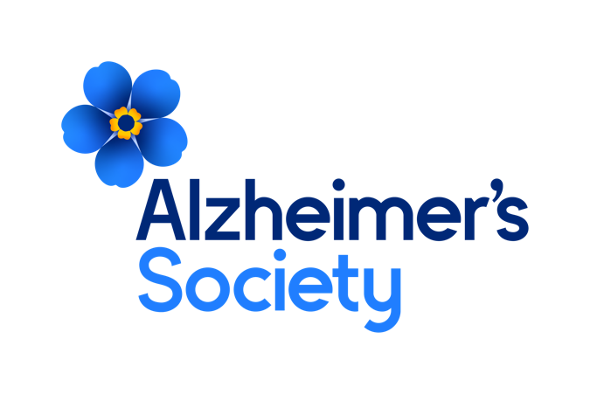



**Senior Governance Officer**

**Job description**

**Together we are help and hope for everyone living with dementia**

**Who we are**

**Our values**

**Dementia is the biggest health and social challenge of our time.**

There are currently estimated to be 900,000 people in the UK with dementia. Many are undiagnosed and facing the realities of their condition alone.

At Alzheimer’s Society we’re working towards a world where dementia no longer devastates lives. We do this by giving help to those living with dementia today and providing hope for the future.

We’re here for everyone living with dementia.

As a Society, we are made up of people with dementia, carers, trusted experts, campaigners, researchers and clinicians. We are the UK’s largest collective force of people with unparalleled knowledge and over 40 years of experience addressing the biggest challenges facing people living with dementia.

**Together we are help and hope for everyone living with dementia.**

Our values tell everyone who we are as an organisation. Our values make sure that our focus is clear for the challenges and opportunities ahead and remind us what we all stand for. Our values are evident in everything we do, how we do it and how we work together.

These are not just words on a wall, we live these every day in all our work. We are Determined to make a difference when and where it matters most, by being passionate, focussed and making a lasting impact for people affected by dementia.



**We’re passionate, we’re focused and we make a lasting impact for everyone living with dementia.**



**We’re listening, we’re learning and we use experience and evidence.**



**We’re open, we combine our strengths and we achieve more together.**



**We’re kind, we’re honest and we don’t shy away from challenges.**

Through our values we will make the greatest difference for people affected by dementia. Whether you are someone living with dementia, a family member or carer, a supporter, a donor, a colleague from another organisation, an employee or a volunteer, these four values will shape your experience with Alzheimer’s Society.

**Position in the Organisation**

**Senior Governance Officer**

Reports to the Head of Governance & Company Secretary.

Member of our Legal and Governance Team.  
Part of our Finance and Assurance directorate.

**Purpose of this Role**

We are here for anyone affected by dementia to help them navigate some of the hardest and most frightening times of their lives.

We are advisors, supporters, fundraisers, researchers, influencers, communicators, technical specialist and so much more. We are volunteers, we are employees, and together we are here to make a difference to the lives of people living with dementia and their carers.

Together with, and reporting into the Head of Governance, this post will ensure the governance team provides effective governance support to the Board of Trustees and its committees. This role will maintain a high-level of organisational knowledge and stakeholder relationships to enable effective and sufficient governance support.

We are looking for someone who exemplifies our values, someone who is: **Determined to make a difference** when and where it matters most. **A Trusted Expert** who believes in working **Better Together** and demonstrates true **Compassion**.

**Key Accountabilities and Responsibilities**

* Providing administrative support to committees (agendas, uploading papers, taking minutes, chasing actions, updating workplans).
* Assisting the Head of Governance to manage the flow of business across internal Society committees and committees of the board.
* Filing returns with Charity Commission and Companies House.
* Assisting with ad hoc projects such as annual report, code compliance, elections, away days.
* Supporting the Head of Governance with subsidiary governance.
* Assisting with general diary administration for the arrangement of governance committees.
* Liaising between administrative staff across the Society, senior management and Trustees.
* Support the preparation and collation of data, reports, papers and presentations as required.
* Undertake any other duties or projects commensurate with the nature and grade of this post as required.
* To adhere to all the Society’s service standards, policies and procedures.
* To comply with the data protection regulations, ensuring that information on clients remains confidential.
* To be responsible for personal learning and development, to support the learning and development of others and the whole organisation.
* To work in a manner that facilitates inclusion, particularly of people affected by dementia.
* To implement the Society’s health and safety policy and procedures, ensuring that all practices and procedures are undertaken in accordance with a healthy and safe working environment and that all staff and volunteers for whom you may be responsible are aware of their responsibilities in respect of their role, monitoring data and recommending action as required.
* To administrate and organise own work to ensure that it is accurate and meets quality targets, reasonable deadlines and reporting requirements.

**We are looking for someone who can…**

* Adhere to all the Society’s service standards, policies and procedures.
* Comply with the data protection regulations, ensuring that information on clients remains confidential.
* Be responsible for personal learning and development, to support the learning and development of others and the whole organisation.
* Work in a manner that facilitates inclusion, particularly of people with dementia.
* Implement the Society’s health and safety policy and procedures, ensuring that all practices and procedures are undertaken in accordance with a healthy and safe working environment and that all staff and volunteers for whom you may be responsible are aware of their responsibilities in respect of their role, monitoring data and recommending action as required.
* Administrate and organise own work to ensure that it is accurate and meets quality targets, reasonable deadlines, and reporting requirements.
* Follow the Society’s management information guidelines and requirements, including ensuring appropriate monthly measures on service usage levels are collected and submitted on the services database or other systems in accordance with deadlines.

**Person Specification and Selection Criteria**

|  |  |  |
| --- | --- | --- |
| **Skills & Knowledge** | **Essential (E) or Desirable (D)** | **Application (A) or Interview (I)** |
| Experience of working in a governance function in a large organisation. | E | A |
| Experience of working with C-Suite/Executive Directors and Trustees/Directors. | E | A |
| Strong communication skills – able to collaborate and work with colleagues across the organisation. | E | A & I |
| Must have experience of writing minutes and turning these around quickly. | E | A & I |
| Experience of chasing actions and getting results from colleagues, particularly senior staff. | E | A & I |
| Experience of attending meetings and understanding the housekeeping required before a meeting (prepping the room/opening the virtual waiting room/connecting IT equipment) and being able to manage these independently. | E | A & I |
| Excellent word processing skills, in particular, using Word, Excel and PowerPoint. | E | A |
| Excellent organisational skills and experience of arranging/co-ordinating meetings, conferences and events. | E | A |
| Able to think independently and work unsupervised. | E | A & I |
| Demonstrably strong written communication skills necessary to draft letters, reports and other documentation. | E | A |
| Excellent interpersonal skills and confident approach in dealing with a wide range of colleagues and stakeholders. | E | A |
| Experience of co-ordinating internal communications across a geographically dispersed organisation. | E | A |
| Degree in a relevant subject. | E | A |
| Experience of governance in a charity. | D | A & I |
| Part or fully ICSA/CGI qualified. | D | A |
| Confident self-starter, able to work on own initiative and as part of a team. | E | A & I |
| Demonstrable ability to plan, prioritise and deliver to tight timescales. | E | A & I |
| Demonstrates a methodical approach and strong attention to detail. | E | A & I |
| Ability to handle sensitive and confidential information in line with the Society’s rules and policies. | E | A |
| An understanding of diversity, and the practical implications of working for an employer with a commitment to equal opportunities. | E | A |
| An understanding of the issues affecting people with Alzheimer’s and other forms of dementia and their carers. | E | A |
| Demonstrable and consistent approach towards others in operating with confidence and integrity. | E | A |
| The ability to influence stakeholders, including senior leaders inside and outside the Society. | E | A & I |
| Ability to work with tact and diplomacy. | E | A & I |
| Ability to create, develop and nurture strong working relationships. | E | A & I |
| Ability to plan, prioritise and deliver complex workloads to tight timescales. | E | A & I |
| Ability to proactively build relationships and trust with internal and external colleagues. | E | A & I |

|  |  |  |
| --- | --- | --- |
| **Competencies & Personal Attributes** | **Essential (E) or Desirable (D)** | **Application (A) or Interview (I)** |
| Excellent communication skills, both verbal and written | E | A & I |
| Work collaboratively and be able to prioritise your workload effectively and remain solution focussed throughout your areas of work. | E | A & I |
| Strong interpersonal and interpretation skills will allow you to have open jargon-free conversations with the business. | E | A |
| Excellent organisational and timekeeping skills. | E | A |
| Excellent attention to detail. | E | A |
| Be a team player, supporting colleagues when there are deadlines, and who knows when to ask for help themselves. | E | A & I |
| Be a self-starter and incredibly motivated. | E | A & I |

Essential requirements are those, without which, the post holder would not be able to fulfil the responsibilities of the role. Desirable requirements are those which would be useful for the post holder to possess and will be considered when more than one applicant meets the essential requirements.

This post will be subject to a satisfactory Criminal Records Check, from either the Disclosure and Barring Service (England & Wales), Disclosure Scotland Check (Scotland) or AccessNI (Northern Ireland). If you require further information regarding Criminal Records Check, then please contact: [careers@alzheimers.org.uk](mailto:careers@alzheimers.org.uk)

