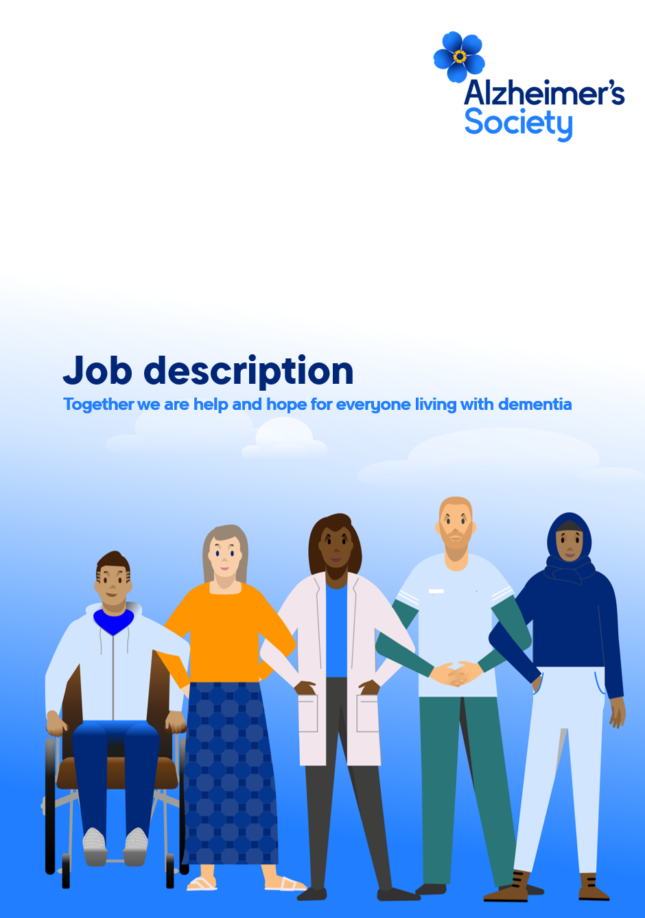
Reporting Analyst – Dementia Services

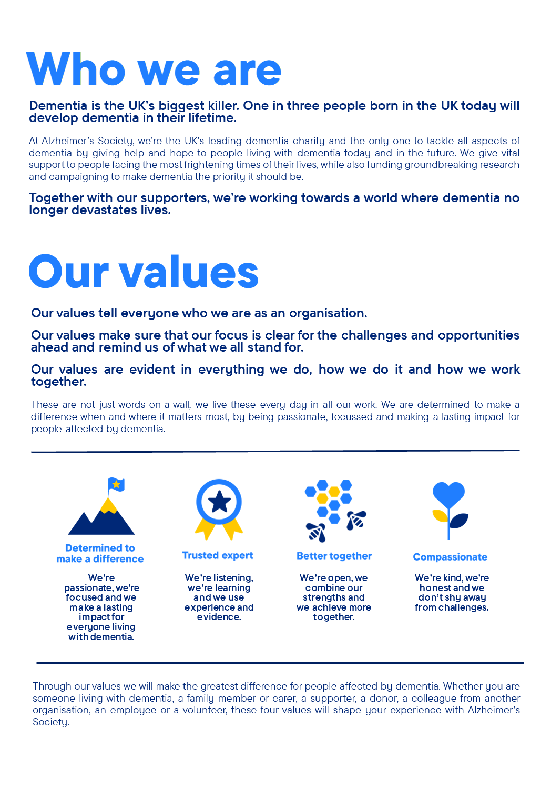

Reporting Analyst – Dementia Services

Position in the organisation
Reports to the Data Insight and Analysis Lead – Dementia Services.
Member of our Quality and Insight team.
Part of our Dementia Support and Partnerships directorate.

Purpose of this role
At Alzheimer’s Society we are advisors, supporters, fundraisers, researchers, influencers, communicators, technical specialist and so much more. We are volunteers, we are employees, and together we are here to make a difference to the lives of people with dementia and their carers.

This is a key role in delivering the Business Intelligence (BI) to enhance our current and future service delivery. You will lead on the requirement gathering, design and creation of high-quality reports and dashboards providing insight across Dementia Support and Partnerships, ensuring these are engaging and accurate. You will bring technical experience with BI software, particularly Power BI, and advanced data manipulation skills – together with the ability to present clearly and innovatively for a range of audiences.

Day-to-day, you will work closely with stakeholders in Dementia Support and Partnerships to agree reporting requirements, quality assure reports, and respond promptly to ad hoc requests. You will undertake maintenance and development of existing reports and dashboards in Power BI under the guidance of the Data Insight and Analysis Lead. You will work smartly to streamline these, identifying shared datasets, following brand style, and putting in place checks to ensure the accuracy and consistency of reported measures.

The role will foster strong relationships with our technology teams, particular in the central Data department – and across the wider reporting and insight community within the Alzheimer’s Society. You will be naturally curious about data and highlight possible patterns and trends for further exploration with the Insight Analyst.

We are looking for someone who exemplifies our values, someone who is: Determined to make a difference when and where it matters most. A trusted expert who believes in working Better together and demonstrates true Compassion.

Key accountabilities and responsibilities

Strategy
- Play a key role in implementing the reporting and insight plan, producing reporting and BI to inform and evidence the directorate’s work.

Reporting development and analysis
- Develop sophisticated dashboards and reports for directorate stakeholders.
- Maintain and develop performance reporting for a range of leadership teams.
- Engage with stakeholders on reporting requirements, translating these into clear specifications
- Produce regular reports and contribute insightful commentary.
- Respond to ad-hoc reporting queries, providing advice and guidance.
- Ensure quality standards and consistency, highlighting data integrity issues.
- Organise testing of new reports and User Acceptance Testing (UAT).

Administration and support
- Provide initial and ongoing support for reporting.
- Collaborate with the reporting and insight community on definitions and standards.
- Regularly review report usage, identifying redundancy and making improvements.
- Ensure data is accurate and complies with the Society’s business rules and Data Protection legislation.
- Identify and implement improvements to procedures relevant to the role and to maintain documentation accordingly.
- Undertake any other duties or projects commensurate with the nature and grade of this post as required.

Other tasks
- Responsible for promoting awareness of available reporting and the insight plan.
- Responsible for proactively identifying new and emerging reporting requirements.

We are looking for someone who can…
- Adhere to all the Society’s service standards, policies and procedures.
- Comply with the data protection regulations, ensuring that information on clients remains confidential.
- Be responsible for personal learning and development, to support the learning and development of others and the whole organisation.
- Work in a manner that facilitates inclusion, particularly of people with dementia.
- Implement the Society’s health and safety policy and procedures, ensuring that all practices and procedures are undertaken in accordance with a healthy and safe working environment and that all staff and volunteers for whom you may be responsible are aware of their responsibilities in respect of their role, monitoring data and recommending action as required.
- Administrate and organise own work to ensure that it is accurate and meets quality targets, reasonable deadlines, and reporting requirements.
- Follow the Society’s management information guidelines and requirements, including ensuring appropriate monthly measures on service usage levels are collected and submitted on the services database or other systems in accordance with deadlines.

Person specification and selection criteria
Competencies & personal attributes | Application (A) or interview (I)
Experience of building high-quality Power BI reports at an intermediate/advanced level, evidencing a range of current techniques and visualisations appropriate for the audience | A/I
Experience of working with complex semantic models (datasets) in Power BI, including writing measures in DAX | A/I
Evidence of using SQL to an intermediate level | A/I
Extensive experience of designing reports and dashboards by co-creating requirements with users | A/I
Experience of working with technical colleagues implementing and supporting data processes | A/I
Experience of writing technical and non-technical documentation for a variety of users | A/I
Advanced Microsoft Office skills: in particular Excel, including data preparation and manipulation functions | A/I
Experience of systems and data within a provider of care and support services | A/I
Experience of working with geographical mapping (GIS) data | A/I
Experience of working with Agile development or project management methodology | A/I

Competencies & personal attributes | Application (A) or interview (I)
Be a team player, supporting colleagues when there are deadlines, and who knows when to ask for help themselves. | A/I
Be a self-starter and incredibly motivated. | A/I
Excellent organisational and timekeeping skills. | A/I
Excellent attention to detail. | A/I
Non-judgemental communication | A/I
Commitment to and understanding of equal opportunities | A
Understanding of the inclusion agenda and its relevance within a diverse society | A

Follow us on Twitter and Instagram @Alzheimerssoc and Like us on Facebook or check out Alzheimer’s Society YouTube channel youtube.com/AlzheimersSociety

